GPRA SURVEYS

Intake GPRAs. In Year 3, a total of 44 intake GPRAs were completed with 36 unique new clients and 8 returning clients from previous years. Demographic data are presented in Table 1 below.

Table 1. Characteristics of Clients Enrolled in Year 3 (n = 44)
Demographic Variable | n | %
Gender  Female  Transgender | 43  1 | 97.7  2.3
Age Group  18 to 24  25 to 34  35 to 44 | 3  23  18 | 6.8  52.3  40.9
Employed full- or part-time | 3 | 6.8
Hispanic or Latinx | 8 | 18.2
Race (n = 38)  Black  Native Hawaiian or Other Pacific Islander  White | 21  1  16 | 47.7  2.3  36.4
High level of education received  Did not finish high school  High school or equivalent  College 1st year completed  Associates degree | 20  14  8  2 | 45.5  31.8  18.2  4.5

Living Situation: Most clients were housed in the past 30 days at intake (n = 29, 65.9%). Of the 29 who were housed, 14 lived at their own apartment, room, or house (31.8%) and 15 lived at someone else’s apartment, room, or house (34.1%). See Figure 1 below.

Figure 1. Clients’ Primary Living Situation in the Past 30 Days at Intake (n = 44)
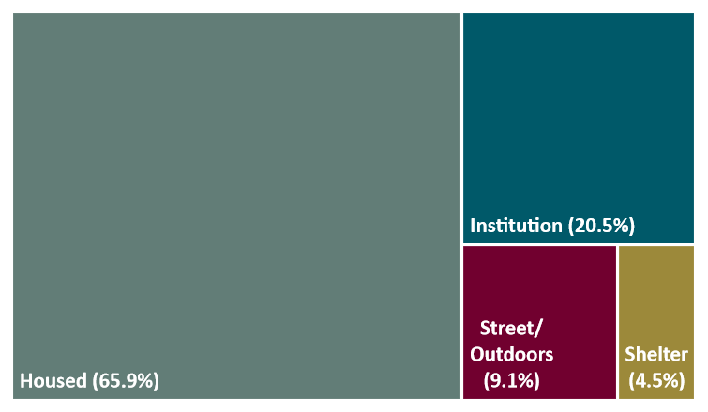

Pregnancy and Children: All 44 clients had children at the time they completed the intake GPRA, with 9 clients currently pregnant (20.5%). The number of children ranged from 1 to 8 children, with the clients having between 2 to 3 children on average (mean = 2.98). Eighteen clients reported having at least one child living with someone else due to a child protection order (40.9%), and 8 clients reporting having lost parental rights for at least one child (18.2%).

Health Status: Over half of the clients reported their health in the past 30 days at intake as good or very good (n = 23, 52.3%), 15 clients reported their health as neither poor nor good (34.1%), and 5 clients reported their health as poor or very poor (11.4%). A majority of clients were satisfied or very satisfied with their health (n = 29, 65.9%), 10 clients were neither satisfied nor dissatisfied (22.7%), and 5 clients were dissatisfied or very dissatisfied (11.4%). Most clients were not at all or slightly bothered by psychological or emotional problems not due to alcohol or drug use (i.e., serious depression; serious anxiety or tension; hallucinations; trouble understanding, concentrating, or remembering; trouble controlling violent behavior; attempted suicide) in the past 30 days (n = 24, 54.6%), 4 clients were moderately bothered (9.1%), and 13 clients were considerably or extremely bothered (29.6%).

Trauma History: Nearly all clients have ever experienced violence or trauma in any setting (n = 41, 93.2%) and have experienced ongoing challenges related to their trauma. Over one in ten clients reported having been hit, kicked, slapped, or otherwise physically hurt (n = 6, 13.7%). See Table 2 below.

Table 2. Impact of Trauma on Clients Enrolled in Year 3 (n = 44)
Impact | # | %
Have had nightmares about it or thought about it when they did not want to | 27 | 61.4
Tried hard not to think about it or went out of their way to avoid situations that reminded them of it | 32 | 72.7
Were constantly on guard, watchful, or easily startled | 35 | 79.5
Felt numb and detached from others, activities, or their surroundings | 25 | 56.8

Substance Use. At intake, 6 clients reported having used both alcohol and drugs on the same day (13.6%, mean = 11.33 days, SD = 11.0). Of those who reported using drugs, 3 clients reported having used a syringe/needle, cooker, cotton, or water that someone else used (6.8%, mean = 5 days, SD = 0.0). See Table 3 below for a breakdown of the average number of days alcohol and different drugs were used in the past 30 days at the time of intake.

Table 3. Alcohol and Drug Use in the Past 30 Days at Intake (n = 44)
Alcohol use in the past 30 days | # clients (%) | Mean # days (SD)
Used any alcohol | 6 (13.6) | 15.8 (12.4)
Had 5+ drinks in one sitting | 3 (6.8) | 21.7 (14.4)
Had 4 or fewer drinks and felt high | 1 (2.3) | 1.0 (N/A)
Drug use in the past 30 days | # clients (%) | Mean # days (SD)
Marijuana | 13 (29.5) | 11.9 (11.6)
Cocaine/crack | 12 (27.3) | 10.8 (10.8)
Benzodiazepines | 9 (20.5) | 7.1 (9.2)
Hallucinogens/psychedelics | 7 (15.9) | 9.0 (9.2)
Percocet | 7 (15.9) | 7.4 (11.4)
Heroin | 4 (9.1) | 7.0 (5.0)
Methamphetamines | 2 (4.5) | 6.5 (5.0)
Oxycontin/Oxycodone | 2 (4.5) | 14.0 (2.8)
Morphine | 1 (2.3) | 8.0 (N/A)

6-Month GPRAs. Between October 1, 2020 through September 30, 2021, a total of 389 contact attempts were made to complete 6-month GPRAs with 38 unique clients eligible to complete a 6-month GPRA. Of these 38 eligible clients, 11 completed a 6-month GPRA (29%). The evaluation team relied primarily on phone calls and text messages to reach clients and their contacts. See Table 4 below for the number of contact attempts and methods used in total and per group.

Table 4. Summary of Contact Attempts to Complete 6-Month GPRAs
Contact Method | Number of Contact Attempts
 | Total Eligible  (n = 38) | Complete  (n = 11) | Not Complete  (n = 27)
Phone Calls | 332 | 63 | 269
Text | 52 | 6 | 46
Email | 5 | 0 | 5
Mail | 0 | 0 | 0
In-Person | 0 | 0 | 0
Social Media | 0 | 0 | 0
Other (e.g., online search) | 0 | 0 | 0
Total | 389 | 69 | 320

As illustrated in Table 5 and Figure 2 below, a client’s discharge status may affect 6-month GPRA completion rates. The evaluation team was more successful at completing GPRAs with clients who successfully completed treatment compared to clients who left the program against facility advice or were administratively discharged.

Table 5. Discharge Status for Clients Eligible for 6-Month GPRA
Discharge Type | Number of Clients
 | Total Eligible  (n = 38) | Complete  (n = 11) | Not Complete  (n = 27)
Against Facility Advice | 16 | 2 | 14
Administrative Discharge | 11 | 4 | 7
Completed Treatment | 8 | 5 | 3
Transfer | 3 | 0 | 3
Total | 38 | 11 | 27

Figure 2. Discharge Type by 6-Month GPRA Completion
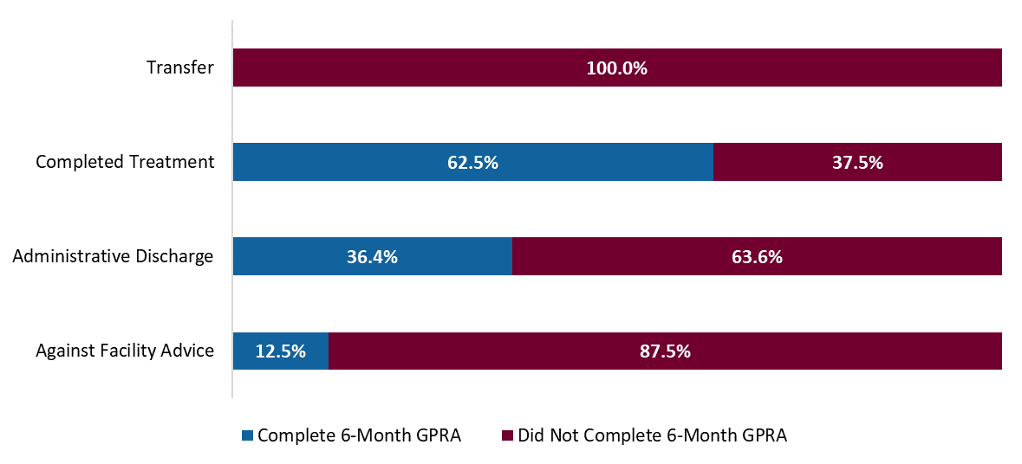

Discharge GPRAs. Between October 1, 2020 through September 30, 2021, a total of 25 contact attempts were made to complete discharge GPRAs with 37 unique clients eligible to complete a discharge GPRA. Of these 37 clients, 8 completed a discharge GPRA (22%). See Table 6 below for a breakdown of discharge types for clients who discharged during this time.

Table 6. Discharge Status for Clients Eligible for Discharge GPRA
Discharge Type | Number of Clients
 | Total Eligible  (n = 37) | Complete  (n = 8) | Not Complete  (n = 29)
Against Facility Advice | 13 | 0 | 13
Administrative Discharge | 9 | 1 | 8
Completed Treatment | 11 | 6 | 5
Transfer | 4 | 1 | 3
Total | 37 | 8 | 29

See Table 7 below for the number of contact attempts and methods used in total and per group.

Table 7. Summary of Contact Attempts to Complete Discharge GPRAs
Contact Method | Number of Contact Attempts
 | Total Eligible  (n = 37) | Complete  (n = 8) | Not Complete  (n = 29)
Phone Calls | 21 | 2 | 19
Text | 4 | 0 | 4
Email | 0 | 0 | 0
Mail | 0 | 0 | 0
In-Person | 0 | 0 | 0
Social Media | 0 | 0 | 0
Other (e.g., online search) | 0 | 0 | 0
Total | 25 | 2 | 23

CONTACT EFFORTS

Challenges and Barriers. The evaluation team experienced a few challenges and barriers to completing GPRAs with clients. Specifically:

- Due to the continuing COVID-19 pandemic, the R&E Group department suspended all in-person data collection activities for several months. This prevented the evaluation team from having anyone on-site to build rapport with clients, collect locator information in-person, and complete GPRAs in-person.
- The contact information that the evaluation and IHW teams collect are self-reported, so sometimes one or both teams receive inaccurate or incomplete contact information that make it difficult to get in touch with clients.
- The evaluation team is not always able to meet with clients to gather locator information if the client unexpectedly leaves the program.

Strategies and Successes. Due to the challenges and barriers mentioned above, the GPRA completion rate is lower than the target 80% rate. In response, the evaluation team brainstormed and implemented several strategies that have yielded successful collection of information. Specifically:

- The evaluation team and IHW staff identified point people for communicating questions and inquiries in a more efficient manner. This has resulted in more timely and informative exchanges of information.
- The IHW team allowed clients access to their cell phones during locator calls so the Interviewers could collect more comprehensive and accurate contact information.
- The Interviewers increased virtual communication with IHW staff since they could not be on-site during the COVID-19 pandemic. Every Monday, an Interviewer emails the IHW staff asking if any clients will be discharged that week and if so, if a call can be arranged between an Interviewer and the client to complete a discharge GPRA before the client leaves the facility.
- Since the Interviewers could not be on-site to introduce themselves and the evaluation to clients, the evaluation team created flyers for both clients and IHW staff that could be posted on-site. The flyers include information on the purpose of the evaluation, what they will be asked to do, and who to contact if they have questions.
- The evaluation team attended multiple CSAT Technical Assistance virtual seminars to receive recommendations on improving our follow-up rate. Some strategies that were recommended are already being implemented by the evaluation team. This includes, but is not limited to: use of locator forms and tracking spreadsheets, providing incentives for completing interviews, and acquiring contact information for various individuals connected to the client (friends, family, probation officers, etc.). Some new strategies we may implement for Year 4 include: using social media to connect with clients, giving clients appointment cards, and giving clients and their children birthday and holiday cards.

NEEDS ASSESSMENTS
Year 2 Needs Assessments. In Year 2, the evaluation team had distributed paper surveys to IHW staff and clients. During this reporting period, the evaluation team analyzed the survey data. Major findings from the clients’ needs assessments are shared below. Findings from the staff needs assessments, and additional findings from the client needs assessments, will be shared with IHW leadership at future continuous quality improvement meetings.

Physical Environment: Collectively, clients rated IHW’s physical space highly. Specifically, all clients agreed that IHW’s facilities are spacious, lively and stimulating, and comfortable, safe, and child-friendly. See Figure 3 below.

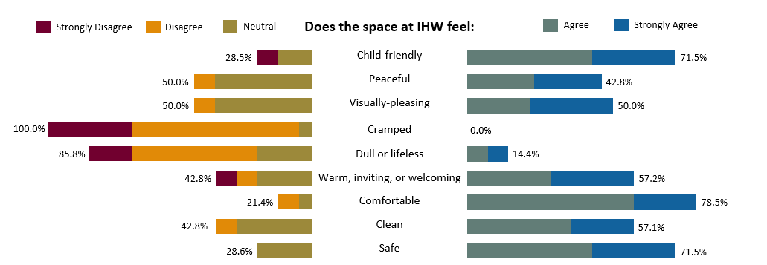
Figure 3. Clients’ Ratings of IHW’s Physical Environment

Physical Activity: A majority of clients (n = 10, 71.4%) reported a desire to go outside more often, and reported feeling that they rarely (n = 6, 42.9%) or never (n = 4, 28.6%) get enough exercise. Clients were asked to list the types of exercises they would like to participate in more. See Figure 4 below for a word cloud; ideas that were more frequently mentioned by clients have bigger font sizes.

Figure 4. Exercises that Clients Would Like to Participate in More

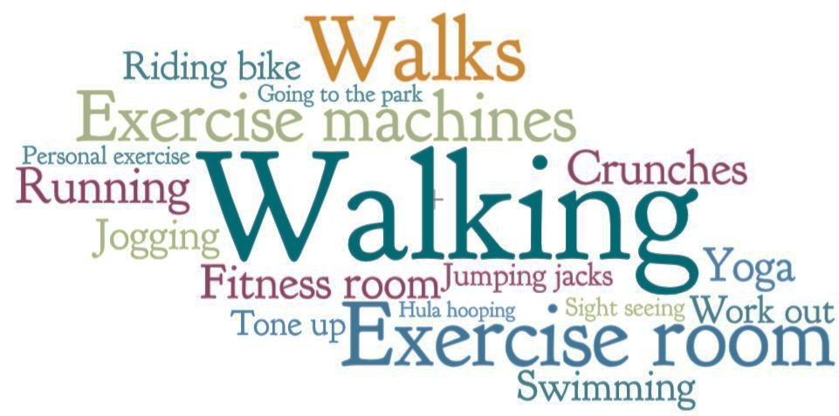

Social Relationships: Half of the clients agreed that their relationships with other people, such as family members, friends, and people at IHW, have improved because of the program (n = 7, 50.0%). Almost half also reported that IHW staff encourage a sense of family or community in the program. See Figure 5 below.

Figure 5. Clients’ Reported Sense of Family or Community at IHW

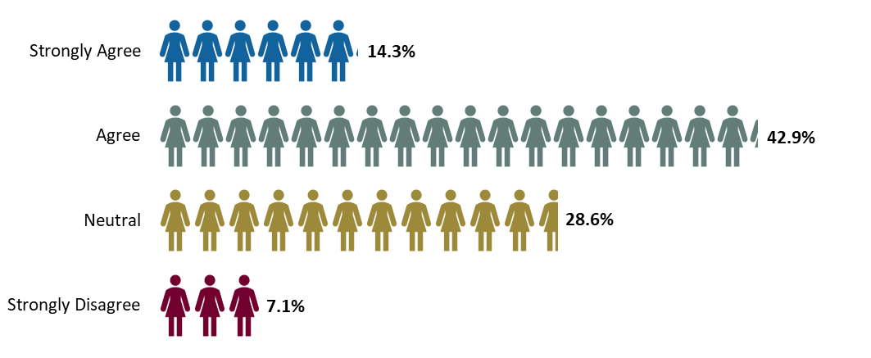

Treatment: Most clients agreed (n = 2, 14.3%) or strongly agreed (n = 7, 50.0%) that, once they leave the program, they will have the tools they need to be successful in their recovery. Similarly, most clients felt that they have made progress towards their treatment program goals; see Figure 6 below. Almost half of the clients agreed (n = 4, 28.6%) or strongly agreed (n = 2, 14.3%) that their treatment is tailored to their individual needs. Overall, nearly all clients agreed (n = 6, 42.9%) or strongly agreed (n = 6, 42.9%) that they trust the IHW care team to meet their treatment needs.

Figure 6. Clients’ Agreement on Making Progress Towards Treatment Goals

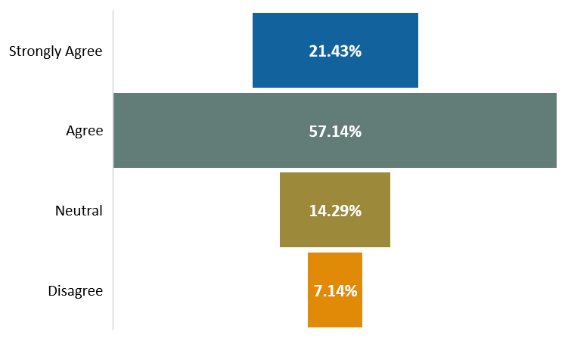

Clients also shared positive ratings about IHW’s counselors:
78.6%
agreed or strongly agreed (n = 11) that their counselor is well organized and prepared for each counseling session

71.4%
agreed or strongly agreed
(n = 10) that their counselor uses a motivating and encouraging approach to help strengthen coping skills

71.4%
agreed or strongly agreed (n = 10) that their counselor provides them with realistic and actionable feedback or advice

Childcare and Parenting: An overwhelming number of clients felt supported as a parent at IHW; see Figure 7 below. Most clients reported having received parenting education at IHW (n = 10, 71.4%), agreed (n = 4, 28.6%) or strongly agreed (n = 28.6%) that there were enough age-appropriate toys for their children, and agreed (n = 4, 28.6%) or strongly agreed (n = 6, 42.9%) that their children were getting the care and attention they needed at IHW. Overall, clients agreed (n = 1, 7.1%) or strongly agreed (n = 6, 42.9%) that IHW staff does a good job taking care of their children, and agreed (n = 4, 28.6%) or strongly agreed (n = 5, 35.7%) that IHW staff are well-trained to take care of their children.

Figure 7. Clients’ Sense of Parenting Support at IHW
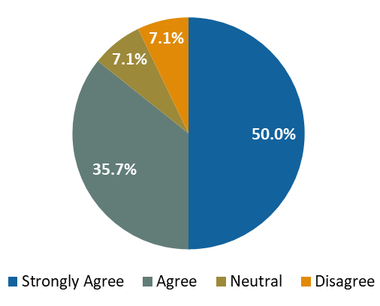

IHW’s Programming: Overall, clients reported satisfaction with the IHW program; see Figure 8 below. Nearly half of the clients agreed (n = 3, 21.4%) or strongly agreed (n = 3, 21.4%) that the program is organized and run well. Since the Year 2 needs assessments were conducted in the middle of the COVID-19 pandemic, clients were asked whether they felt IHW staff were doing a good job keeping them safe from COVID-19; most clients reported feeling usually (n = 7, 50.0%) or always (n = 4, 28.6%) safe during this time.

Figure 8. Clients’ Satisfaction with the IHW Program

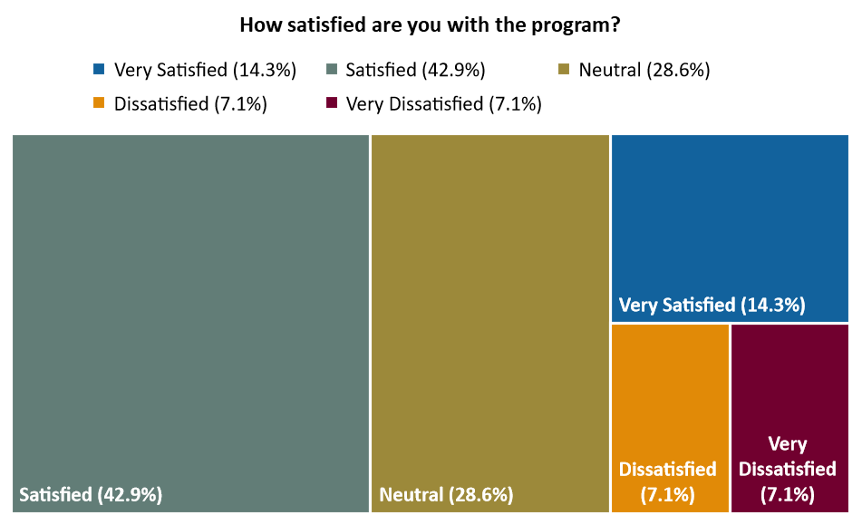

Year 3 Needs Assessments. During this reporting period, the evaluation team conducted the annual needs assessments with both IHW staff and clients

Staff Needs Assessments: The evaluation team developed paper surveys that included questions on program facilities and resources, work culture, training needs, and the Family Resilience Project. The Lead Evaluator distributed the paper surveys on-site. The surveys were accompanied by a cover sheet that emphasized the importance and confidentiality of staff’s responses. The Lead Evaluator collected paper surveys from staff the same day. For staff who were not available at that time, the Lead Evaluator left paper surveys that staff later completed and anonymously put in envelopes, which were then picked up by evaluation staff.

Client Needs Assessments: Similarly, clients were asked to complete paper surveys that included questions on program facilities and environment, treatment services, parenting support, relationship with staff, family member engagement, and IHW’s response to the COVID-19 pandemic. Clients with young children or who had been or were currently pregnant during their IHW stay were asked to complete a supplemental survey that asked about childcare services and pre- and post-natal care. The Lead Evaluator explained the rationale for the needs assessment, how clients’ responses will be used to strengthen the program for future clients, and the confidentiality of all responses. The Lead Evaluator and Interviewer collected paper surveys from on-site clients. In subsequent visits, the Lead Evaluator and Interviewer completed additional needs assessments with clients who had been unavailable initially.

All paper surveys will be entered into a database for future analyses. Findings and recommendations from the Year 3 needs assessments will be shared with IHW staff to improve IHW’s program and reported in the next annual report.

